Python Database Programming Exercise
This Database exercise Project will help Python developers to learn database programming skills quickly. In this exercise, we will perform database CRUD operations using Python.
Note:
This exercise covers the following three popular database servers. You can choose the database server you are familiar with to solve this exercise.
- MySQL
- PostgreSQL
- SQLite
You can use any driver (DB module) as per your wish, for example, there are more than 5 libraries are available to communicate with MySQL. In this exercise, I am using the following libraries.
- MySQL: mysql connector python
- PostgreSQL: psycopg2
- SQLite: sqlite3

This Python database programming exercise includes: –
Now it has 5 exercise questions, which simulate the real-time queries, and each question contains a specific skill you need to learn. When you complete the exercise, you get more familiar with database operations in Python.

Exercise/mini Project: Hospital Information System
In this exercise, We are implementing the Hospital Information System. In this exercise, I have created two tables, Hospital and Doctor. You need to create those two tables on your database server before starting the exercise.

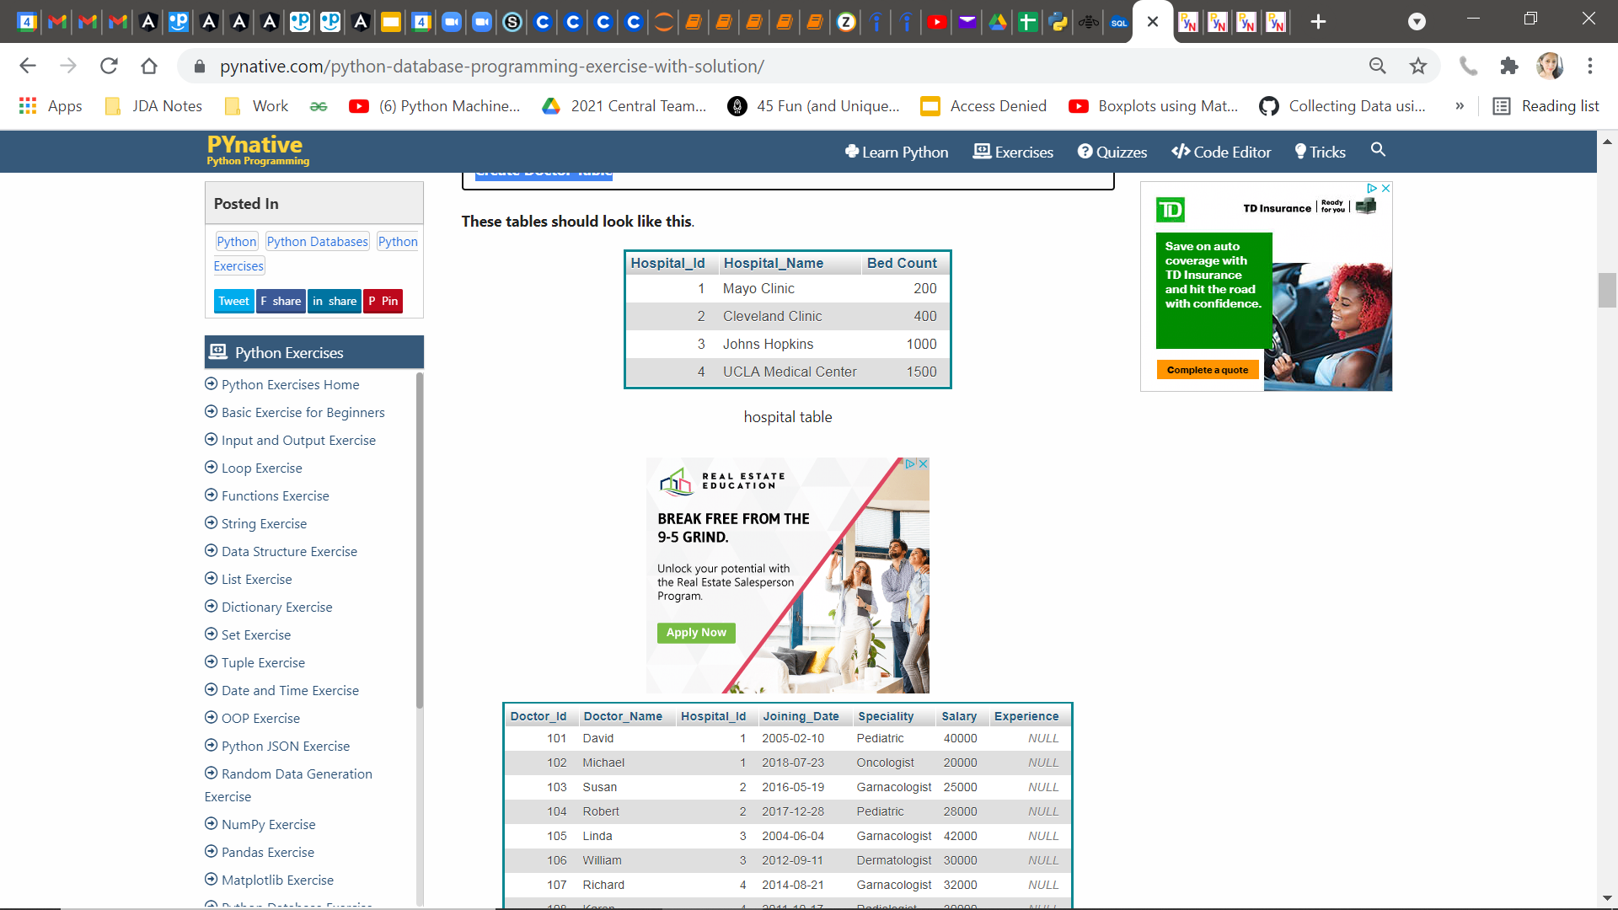
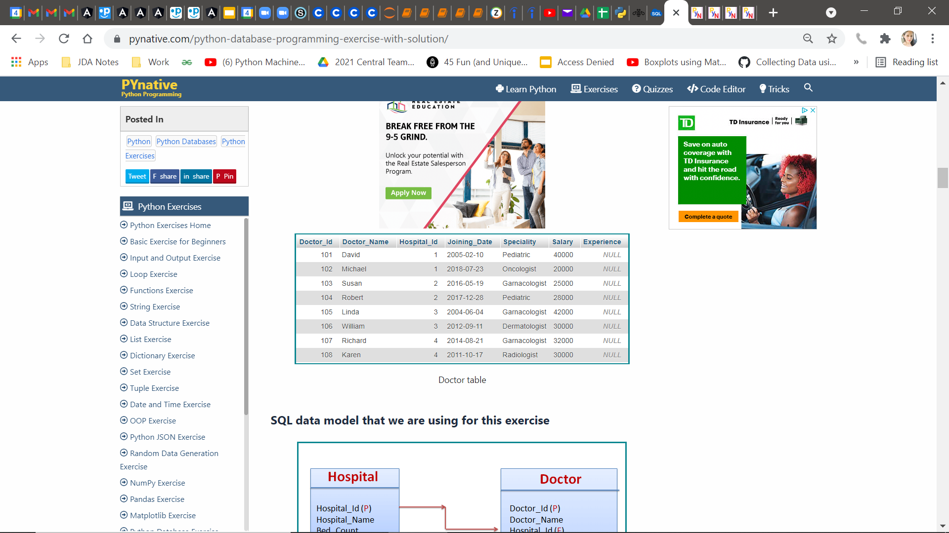

Exercise 1: Connect to your database server and print its version

Exercise 2: Fetch Hospital and Doctor Information using hospital Id and doctor Id

Exercise 3: Get the list Of doctors as per the given specialty and salary

Exercise 4: Get a list of doctors from a given hospital

Exercise 5: Update doctor experience in years

